**PROJECT DEVELOPMENT PHASE**

**SPRINT-4**

|  |  |
| --- | --- |
| **TEAM ID** | **PNT2022TMID28768** |
| **PROJECT NAME** | **Visualizing and Predicting Heart**  **Disease with an Interactive Dash** **Board** |

**SPRINT 4: ST DEPRESSION**

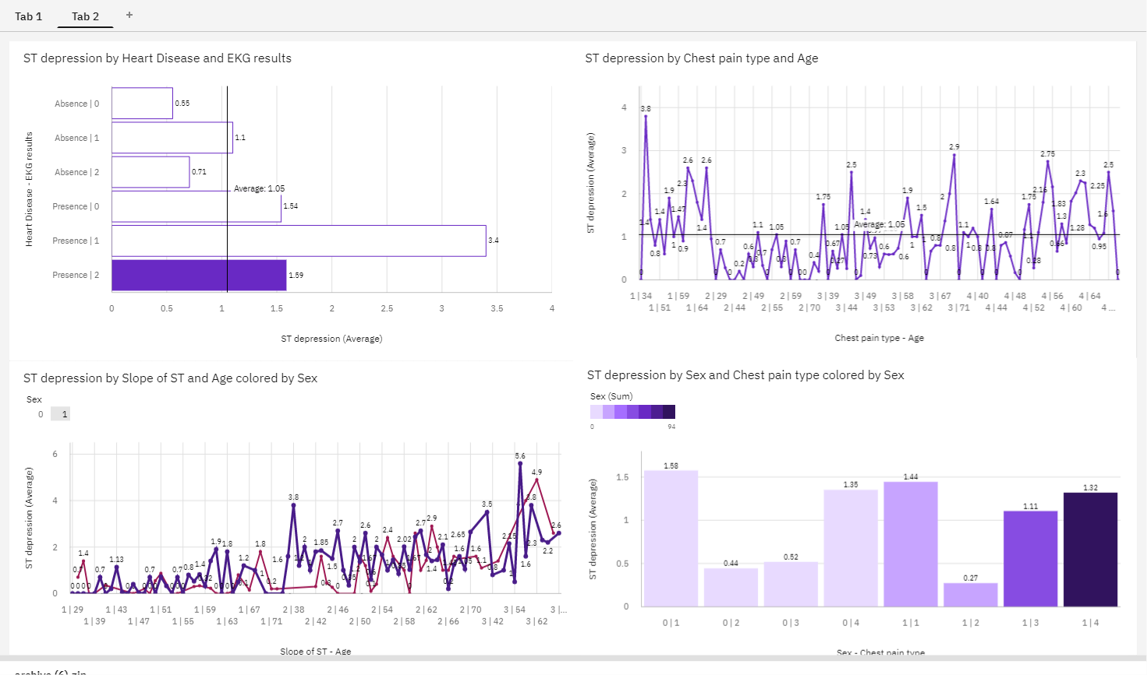

**INTRODUCTION:**

The ST segment is the line between the “S” and the “T” on the

readout of an EKG. If a person is in good health, the line appears at or close to the baseline level. A depressed or elevated ST segment can indicate the presence of an underlying health condition. **ST depression** refers to a finding on an [electrocardiogram,](https://en.wikipedia.org/wiki/Electrocardiogram) wherein the trace in the [ST segment](https://en.wikipedia.org/wiki/ST_segment) is abnormally low below the baseline.

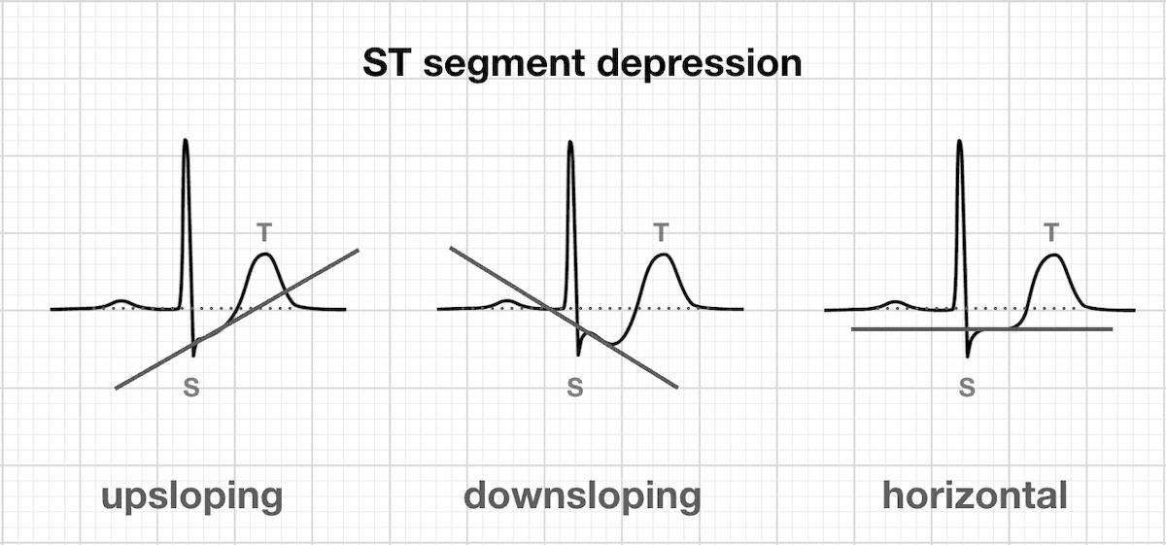

**Causes:**

It is often a sign of myocardial [ischemia,](https://en.wikipedia.org/wiki/Ischemia) of which [coronary](https://en.wikipedia.org/wiki/Coronary_artery_disease)

[insufficiency](https://en.wikipedia.org/wiki/Coronary_artery_disease) is a major cause. Other [ischemic heart diseases](https://en.wikipedia.org/wiki/Ischemic_heart_disease) causing ST depression include:

Subendocardial ischemi or even infarction Subendocardial means non full thickness ischemia. In contrast, [ST elevation](https://en.wikipedia.org/wiki/ST_elevation) is transmural (or full thickness) ischemia

**Non Q-wave** [**myocardial infarction**](https://en.wikipedia.org/wiki/Myocardial_infarction)**:**

Reciprocal changes in acute Q-wave myocardial infarction (e.g., ST depression in leads i & aVL with acute inferior myocardial infraction) Depressed but *upsloping* ST segment generally rules out ischemia as a cause.

Also, it can be a normal variant or [artifacts,](https://en.wikipedia.org/wiki/Visual_artifact) such as:

* Pseudo-ST-depression, which is a wandering [baseline](https://en.wikipedia.org/wiki/Isoelectric_line) due to poor skin contact of the electrode
* Physiologic J-junctional depression with sinus tachycardia

|  |  |
| --- | --- |
|  |  |
|  |

Other, **non-ischemic**, causes include:

* Side effect of [digoxin](https://en.wikipedia.org/wiki/Digoxin)
* [Hypokalemia](https://en.wikipedia.org/wiki/Hypokalemia)
* Right or left [ventricular hypertrophy](https://en.wikipedia.org/wiki/Ventricular_hypertrophy)
* Intraventricular conduction abnormalities (e.g., [right](https://en.wikipedia.org/wiki/Right_bundle_branch_block) or [left](https://en.wikipedia.org/wiki/Left_bundle_branch_block) [bundle branch block,](https://en.wikipedia.org/wiki/Bundle_branch_block) WPW, etc.)
* [Hypothermia](https://en.wikipedia.org/wiki/Hypothermia)
* [Tachycardia](https://en.wikipedia.org/wiki/Tachycardia)
* Reciprocal ST elevation
* [Mitral valve prolapse](https://en.wikipedia.org/wiki/Mitral_valve_prolapse)
* [Central nervous system disease,](https://en.wikipedia.org/wiki/Central_nervous_system_disease) such as [stroke](https://en.wikipedia.org/wiki/Stroke)

**Mnemonic:**

A [mnemonic](https://en.wikipedia.org/wiki/Mnemonic) can be used for some causes of ST depression, namely *DEPRESSED ST*.

**D** - Drooping valve [(mitral valve prolapse)](https://en.wikipedia.org/wiki/Mitral_valve_prolapse) **E** - Enlargement of the left ventricle **P** - Potassium loss **R** - Reciprocal ST depression (e.g. inferior wall

MI) **E** - Encephalon hemorrhage **S** - Subendocardial infarct **S** Subendocardial ischemia **E** - [Embolism (pulmonary)](https://en.wikipedia.org/wiki/Pulmonary_embolism) **D** - [Dilated cardiomyopathy](https://en.wikipedia.org/wiki/Dilated_cardiomyopathy) **S** - Shock **T** - Toxicity ([digitali](https://en.wikipedia.org/wiki/Digoxin)[s/quinidine)](https://en.wikipedia.org/wiki/Quinidine)

**Physiology:**

For non-transmural ischemia (subendocardial ischemia) injured cells are closer to the inside of heart wall, resulting in a systolic injury current. A systolic injury current results from a greater depolarization in healthier cells. Because the subepicardial region is more depolarized (more positive) compared to the endomyocardial cells, the current in the left ventricle flows toward the endomyocardial cells. The current flows from the more positive subepicardium to the less positive subendocardium during phase 2 of the fast fiber type depolarization, which on ECG occurs during ST segment. The positive electrodes on the anterior chest wall detect the movement of positive charge away from the electrode and record it as a downward deflection on the ECG paper.

**Junction (J) Point:**

The junction (J) point is where the QRS complex and ST segment meet. It marks the beginning of the ST segment. Any displacement of the ST segment above or below baseline is often measured at the J point. For

instance, diffuse J points can be seen with early repolarization, pericarditis, left ventricular hypertrophy (LVH) with strain, and acute myocardial infarctions (MI). Because it is often difficult to make out the J point and/or

the beginning of the T wave, the ST segment is frequently an approximation or evaluated at ST, which is the ST segment at 60 ms after the J point.

**Reference Point:**

The reference point used in determining if the ST segment is elevated or depressed has been an area of dispute. The debate tends to be between using the PQ junction which is the end of the PR segment, or the TP segment. This is because the PQ junction and TP segment may not always be at the same level. While the ventricles depolarize, the atria are repolarizing and can affect the level of the PQ junction. Hence, both the PQ junction and the PR segment cannot be the correct reference point.

The American College of Cardiology/American Heart Association joint guidelines recommend that the PQ junction be used as the reference point. Vectorcardiographic analysis suggests that if the QRS-vector loop ends at the point of origin, then the loop is considered closed and there will be no ST-segment deviation. However, if the QRS-vector loop does not end at the onset of ventricular depolarization, then the loop is considered open and there can be ST-segment deviation. Another fact supporting the use of the PQ junction as the reference is that the TP segment may not always be present. For instance, with sinus tachycardia the P wave may be superimposed on the T wave, resulting in the absence of a TP segment. Thus, the PQ junction (end of the PR segment) seems like the better reference point in evaluating for ST segment deviation.

**Measurement:**

ST segment depression may be determined by measuring the vertical distance between the patient's trace and the [isoelectric line](https://en.wikipedia.org/wiki/Isoelectric_line) at a location 2-3 millimeters from the [QRS complex.](https://en.wikipedia.org/wiki/QRS_complex)It is significant if it is more than 1 mm in V5-V6, or 1.5 mm in AVF or III.

In a [cardiac stress test,](https://en.wikipedia.org/wiki/Cardiac_stress_test) an ST depression of at least 1 mm after [adenosine](https://en.wikipedia.org/wiki/Adenosine) administration indicates a reversible ischaemia, while an exercise stress test requires an ST depression of at least 2 mm to significantly indicate reversible ischaemia.

**Characterizing the ST Segment:**

The ST-segment can have multiple morphological variations. However, regardless of condition influencing the ST segment, the ST segment can either become displaced above baseline (ST elevation) or below baseline (ST depression). It is also important to evaluate the waveform of the ST segment. Displacement of the J point can be further characterized as horizontal, upsloping, or downsloping; the latter two can be rapid or slow. For example, ST elevation in leads V and V can be described as rapidly downsloping, and in such cases, it is typically benign. These further characterizations of the ST segment can help differentiate between normal and ischemic conditions. For instance, ST elevation with an upsloping ST segment is generally considered normal, while ST

elevation with a horizontal ST segment is more characteristic of myocardial ischemia. Therefore, knowing the distinguishing and unique ST segment

morphologies of certain conditions can be extremely helpful clinically.

The T wave should also be considered when assessing the ST

segment. In general, myocardial ischemia is represented by ST depression and symmetric T-wave inversion (TWI), while myocardial injury may be indicated by ST elevation with or without T wave changes. T waves should normally be positive in leads I, II, and V-V, and negative in lead aVR. There are many other aspects to consider when evaluating the T wave that are outside the scope of this manuscript. In the remaining sections, we will focus on variations that can be seen with ST elevation and depression and

their causes.

**ST Elevation:**

ST elevation occurs when the J point is displaced above baseline. While ST elevation is thought to be an emergent condition in the acute setting and recognized as a sign of an occlusive thrombus, this is not always the case. There are many conditions that can mimic the ST

elevation seen in acute MI and simply represent normal variations. In fact,

early repolarization, LVH, ventricular aneurysm, left bundle branch block, and other conduction defects have been shown to be more common causes of ST elevation than acute MIs.There are three common causes of ST elevation. The first is when ST elevation can simply be a normal variant. This often is referred to as early repolarization. In such cases, there tends to be J-point elevation with a normal or rapidly upsloping ST segment.

**Exercise-induced ST depression in the diagnosis of coronary artery**

**disease. A meta-analysis**

To evaluate the variability in the reported diagnostic accuracy of the exercise electrocardiogram, we applied meta-analysis to 147 consecutively published reports comparing exercise-induced ST depression with coronary angiography. These reports involved 24,074 patients who underwent both tests.Population characteristics and technical and methodologic factors, including publication year, number of electrocardiographic leads, exercise protocol, use of hyperventilation, definition of an abnormal ST response, exclusion of certain subgroups, and blinding of test interpretation were analyzed.Wide variability in sensitivity and specificity was found (mean sensitivity, 68%; range, 23-100%; SD, 16%; and mean specificity, 77%; range, 17-100%; SD, 17%).The four study characteristics found to be significantly and independently related to sensitivity were the treatment of equivocal test results, comparison with a "better" test such as thallium scintigraphy, exclusion of patients on digitalis, and publication year.The four variables found to be significantly and independently related to specificity were the treatment of upsloping ST depressions, the exclusion of subjects with prior infarction or left bundle branch block, and the use of preexercise hyperventilation. Stepwise linear regression explained less than 35% of the variance in sensitivities and specificities reported in the 147 publications. There is wide variability in the reported accuracy of the exercise electrocardiogram. This variability is not explained by information reported in the medical literature.

**Conclusion:**

The ST segment represents an important feature of the ECG

complex. It can show characteristic features that can help differentiate certain conditions it summarizes the differential diagnosis for both ST elevation and depression as well as unique ST-segment morphologies and associated ECG findings that may be seen with each. Being familiar with these characteristic findings along with other ECG and clinical features can aid in accurate diagnosis, management, and treatment.